**Save The Date!**

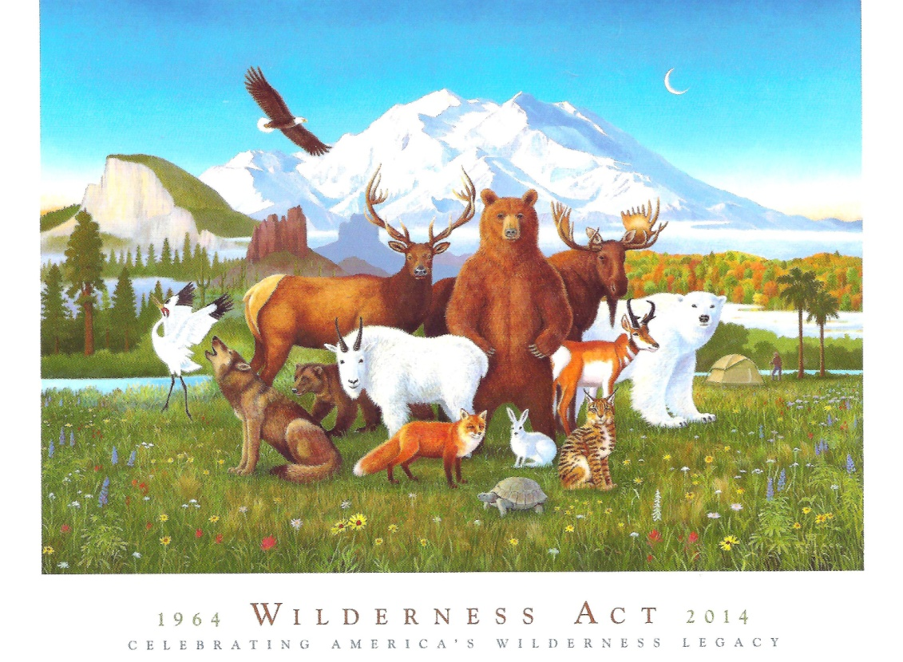

*Please join the NC Sierra Club in*

*Celebration of the 50th Anniversary of the Wilderness Act!*

***Friday September 26 – Saturday September 27***

[***Morrow Mountain State Park***](http://www.ncparks.gov/Visit/parks/momo/main.php)

*Albemarle, NC*

*Activities include canoeing, hiking, service, birding, fishing, star-gazing*

*and a special guided tour of the Kron restoration.*

***Celebratory dinner Saturday at 5:30pm at the Morrow Mountain Lodge***

*Barbeque and fixin’s or Vegetarian Lasagna*

*Mixed Green Salad*

*Wilderness Birthday Cake*

***Program***

*Park Ranger Ron Anundson on the History of Morrow Mtn. St Pk*

*Keynote Speaker - Brent Martin, The Wilderness Society*

*Backcountry Travelogue with Jerry Weston*

***Watch for registration details in August Footnotes Online!***

*Contact Nancy Card,* [*OurWildNC@gmail.com*](mailto:OurWildNC@gmail.com)*, 910-540-3088*